Student  Full Name: | Student  Number:
Subject:  PFD47XS Professional Development/Methods | Test Date:  5 April 2023 | Duration:  1.5 hours

Test 1
Faculty of Informatics & Design
Course:
Advanced Diploma in Information Technology
Question | Student Mark | Max. Score
1 |  | 10
2 |  | 20
3 |  | 15
4 |  | 20
 |  | 80

Subject Coordinator:
Mr T. Makhurane
Lecturers / Examiners:
Mr T. Makhurane
Special instructions:
Answer ALL 4 questions.
Requirements:
Students should not leave within the first hour even if they have completed.
Hand-in question paper together with the answer book at the end of examination

%

Question 1  Figure 1 |  | [10]
1.1 | How are Mintzberg’s managerial roles applicable to the work of software project managers?  Answers:  Interpersonal role:  - Figurehead: which represent the team and the company at the meeting and conference.  - Leaders: which represents the team, motivates the team members and ensure efficiency.  - Liaison: which communicate with stakeholder, sponsors and the external vendors.  Informational roles:  - Monitors: which tracks the project progress, identify the risks, and collect the performance data.  - Disseminator: which share the important project information with team members.  - Spokesperson: which reports the project updates to senor or management and clients.  Decision role:  - Entrepreneur: it innovates and implement the solution to project challenges.  - Disturbance handler: it resolves the conflicts and technical issues.  - Resource allocator: it assigns the tasks, manage the budget, and optimize the resources of a project.  - Negotiator: this one, works with the clients, vendors and stakeholders to finalize the project terms. | [10]
Question 2 |  | [20]
Given the following information:

Assumptions:
- A Five Day Working Week (Monday to Friday),
- Work for 8 Hours each Day.

 | Activity | Duration | Predecessor | Resources
2 | System Design | 12 | -
3 | Define work process | 3 | - | Project Manager
4 | Identify required information and resources | 2 | 3 | Project Manager
5 | Design software system to support work process | 5 | 4
6 | Basic software | 3 | 4 | Business Analyst, Developer, User
7 | Data access required | 1 | 6 | Business Analyst, Developer, User
8 | Vendor software required | 1 | 7 | Business Analyst, Developer, User
9 | Identify required hardware components | 2 | 8,5 | Business Analyst

And this resource sheet

Resource | Cost/Hour
Project Manager | R 300.00/hour
User | R 150.00/hour
Business Analyst | R 100.00/hour
Developer | R 90.00/hour
Buyer | R 80.00/hour

2.1 | Sketch a Gantt chart to represent the information given in the table above. | [6]
2.2 | How many days does it take to complete all activities up to and including activity 9?  Answer:  To determine the total duration, you would sum the durations of all activities up to and including activity 9, considering any dependencies. Based on the table, the total duration would be 29 days. | [6]
2.3 | What does it cost to complete all these activities?  Step 1: Calculate Cost per Activity  Formula:  Cost=Duration (Days)×8 hours/day×Cost per HourCost=Duration (Days)×8 hours/day×Cost per Hour  NB: To get the cost to complete all these activities please follow the screenshots below and use the formula above.  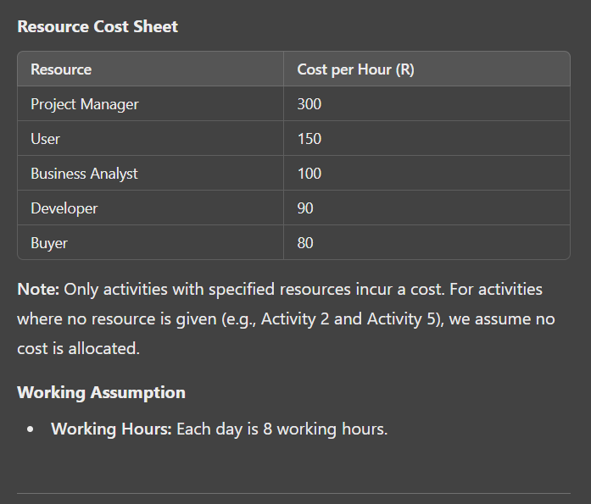  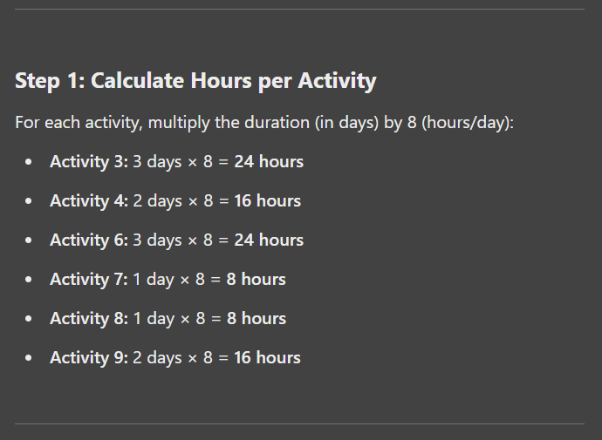  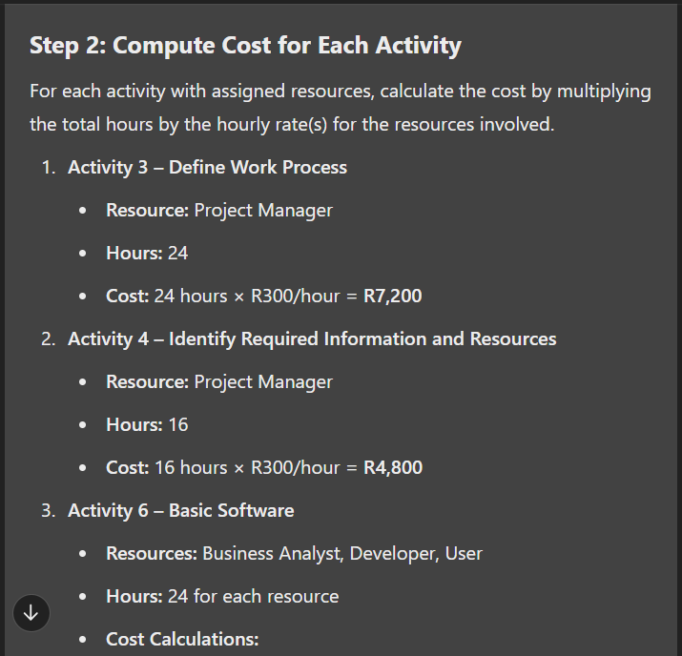  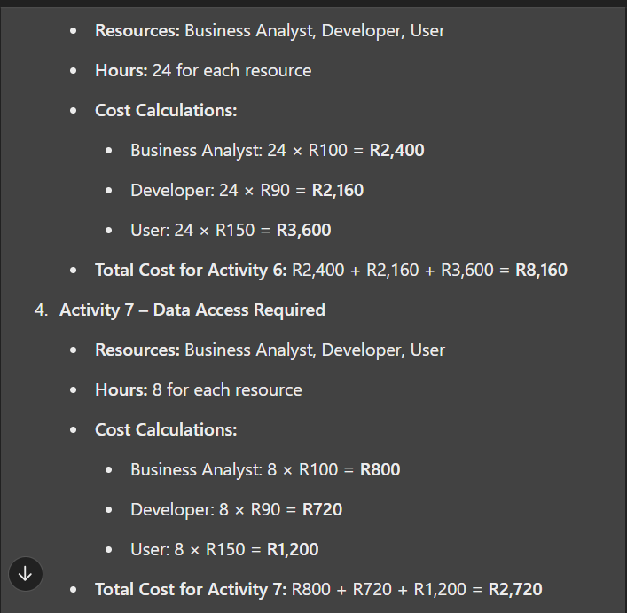  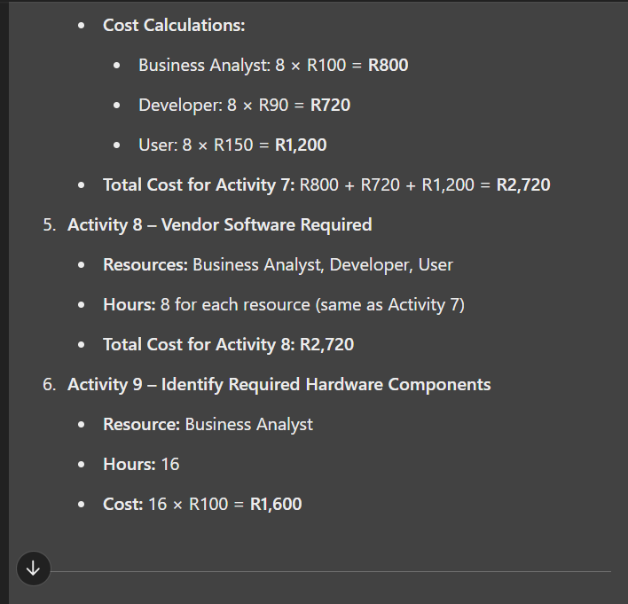  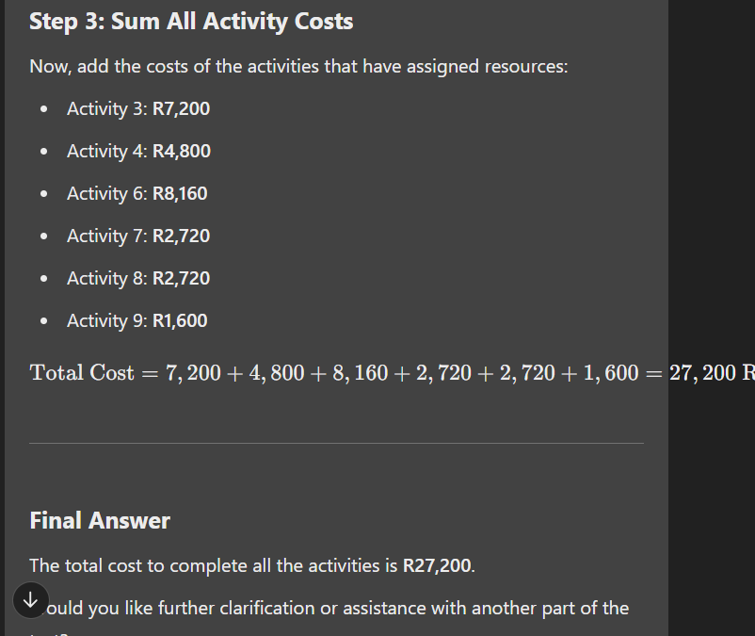 | [8]
Question 3 |  | [15]
Activity | Time | Precedents
A | 2 | -
B | 3 | A
C | 4 | -
D | 4 | C
E | 2 | B
F | 2 | A,D
G | 9 | E,F

3.1 | Construct a network diagram given the table above. | [7]
3.2 | Calculate the early start and late start values for each node on the diagram.  Step 3: Forward Pass Calculation (ES & EF) (Calculations for early start values for each node)  We process activities from start to finish, updating ES and EF:  - Activity A (No predecessor)  - ES = 0 (starts at day 0)  - EF = ES + Duration = 0 + 2 = 2  - Activity B (Predecessor: A)  - ES = EF of A = 2  - EF = ES + Duration = 2 + 3 = 5  - Activity C (No predecessor)  - ES = 0 (can start at day 0)  - EF = ES + Duration = 0 + 4 = 4  - Activity D (Predecessor: C)  - ES = EF of C = 4  - EF = ES + Duration = 4 + 4 = 8  - Activity E (Predecessor: B)  - ES = EF of B = 5  - EF = ES + Duration = 5 + 2 = 7  - Activity F (Predecessors: A, D)  - ES = max(EF of A, EF of D) = max(2, 8) = 8  - EF = ES + Duration = 8 + 2 = 10  - Activity G (Predecessors: E, F)  - ES = max(EF of E, EF of F) = max(7, 10) = 10  - EF = ES + Duration = 10 + 9 = 19  Calculations for latest start for each activity are as follows:  Backward Pass: Latest Start (LS) and Latest Finish (LF) Calculations  Now, we will perform the Backward Pass to calculate:  - Latest Finish (LF): The latest time an activity must finish without delaying the project.  - Latest Start (LS): The latest time an activity can start without delaying the project.  Formulae:  LS=LF−DurationLS = LF - \text{Duration}LS=LF−Duration  Step 1: Set LF for the Last Activity (G)  - Activity G:  - Since it's the final activity, LF = EF = 19.  - LS = LF - Duration = 19 - 9 = 10.  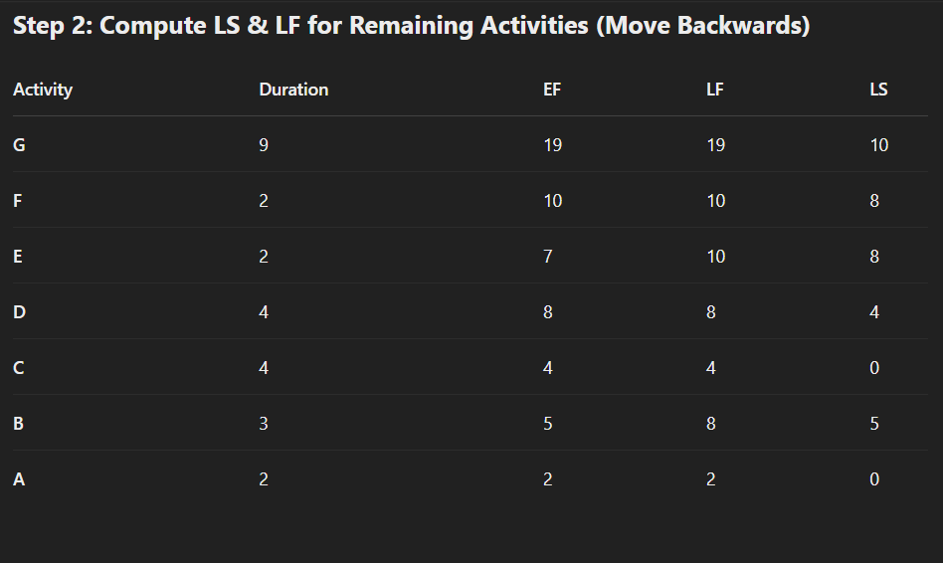 | [7]
3.3 | Identify the critical path | [1]
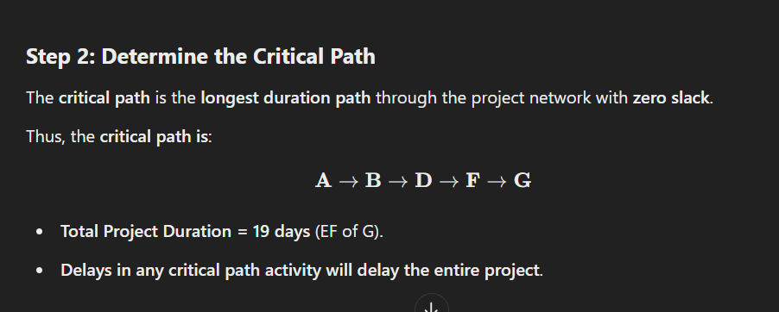
Question 4 |  |  | [20]
Given the predecessor/duration table for a PERT network

Activity | Optimistic Time | Most Likely Time | Pessimistic Time | Predecessor Activities
A | 1 | 3 | 5 | -
B | 1 | 2 | 3 | -
C | 4 | 6 | 7 | A,B
D | 3 | 5 | 8 | C
E | 2 | 3 | 5 | D
F | 1 | 3 | 4 | C
G | 3 | 4 | 5 | F
H | 5 | 6 | 7 | E
I | 4 | 5 | 7 | G, H

4.1 | Draw the PERT network  You can draw this by yourself on a piece of paper |  | [4]
4.2 | Calculate the expected finish time $(µ)$.   |  | [7]
4.3 | Identify the longest path.  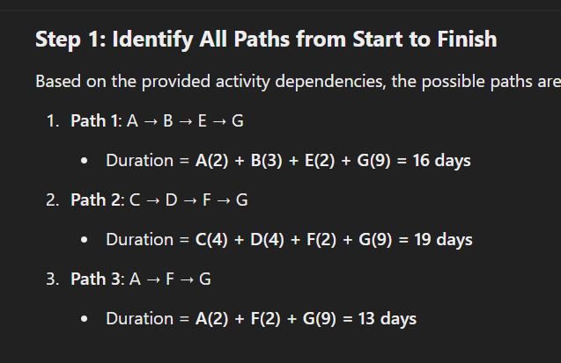  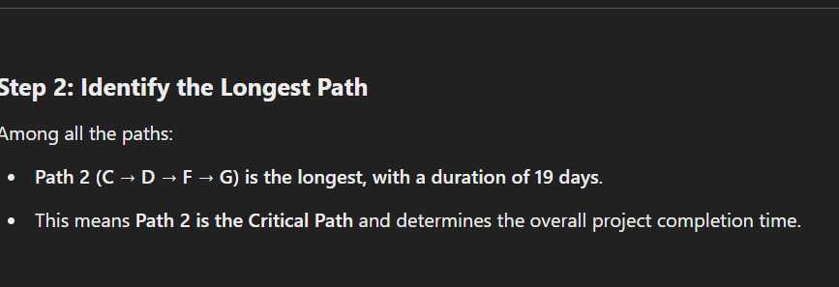 |  | [1]
4.4 | Determine the likelihood (probability) of finishing at time 29. |  | [4]
4.6 | By what time is there a 95% likelihood of finishing the project? |  | [4]

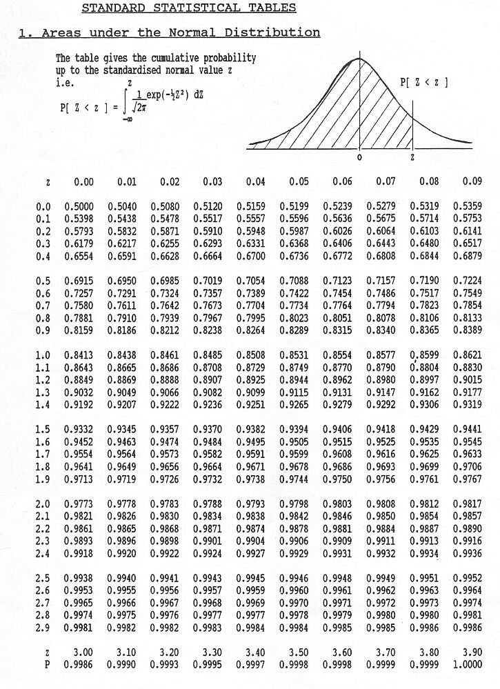
Additional Formulas
$$PV=\frac{FV}{{\left(1+r\right)}^{n}}$$

